Requirement Analysis Phase-II
Data Flow Diagram & User Stories

Date | 10-02-2026
Team ID | LTVIP2026TMIDS65437
Project Name | Flavour Fusion: - Ai-Driven Recipe Blogging
Maximum Marks | 4 Marks

Data Flow Diagrams:
Data Flow Diagram (DFD): - A Data Flow Diagram (DFD) for an AI-Driven Recipe Blogging system, such as "Flavour Fusion," illustrates how food imagery and user preferences are transformed into recipes, step-by-step instructions, and blog content.
Based on AI-driven culinary applications, the data flow primarily involves three phases:
1. Input Processing
2. AI Analysis & Generation
3. Output Storage & Display
Data Flow Diagram Components: -
A.Input Data Flow (Image/Ingredients to AI)
- Image Upload: The user uploads a photo of a dish (e.g., paneer gravy) via the web interface.
- Ingredient Input: Alternatively, the user enters text-based ingredients.
- Data Transmission: Raw image data is sent to the AI processing unit.
B. Processing Data Flow (AI Analysis)
- Image Recognition (CNN): A Convolutional Neural Network (CNN) analyzes the photo to identify ingredients and the dish type.
- Recipe Generation (RNN/LLM): A Recurrent Neural Network (RNN) or Large Language Model (LLM) takes the recognized ingredient set and generates step-by-step instructions, including preparation and cooking time.
- Validation: The generated recipe is checked for accuracy and coherence.

C. Output & Storage Data Flow (Data Repository)
- Store Recipe Data: The system stores the generated title, ingredients, and instructions in a SQL or NoSQL database.
- Store Metadata: Tags, cooking time, and difficulty levels are stored.
- Display Output: The final recipe is published to the blog UI for the user.
Detailed Data Flow Description (Step-by-Step)
- Input: User uploads a food image.
- Analysis: The CNN model identifies the dish, ingredients, and style.
- Generation: The RNN model creates a tailored recipe based on the image.
- Refinement: The AI adds nutritional info, preparation time, and tips.
- Storage: The complete, generated recipe is stored in the Data Store.
- Display: The blog platform fetches the data and displays the formatted recipe to the user.
Key Technologies
- CNN (Convolutional Neural Networks): For food recognition.
- RNN/LSTM (Recurrent Neural Networks): For generating sequential cooking instructions.
- Database: Structured storage for ingredients and instructions.
This system is designed to turn visual input into a bloggable, structured, and personalized cooking experience.

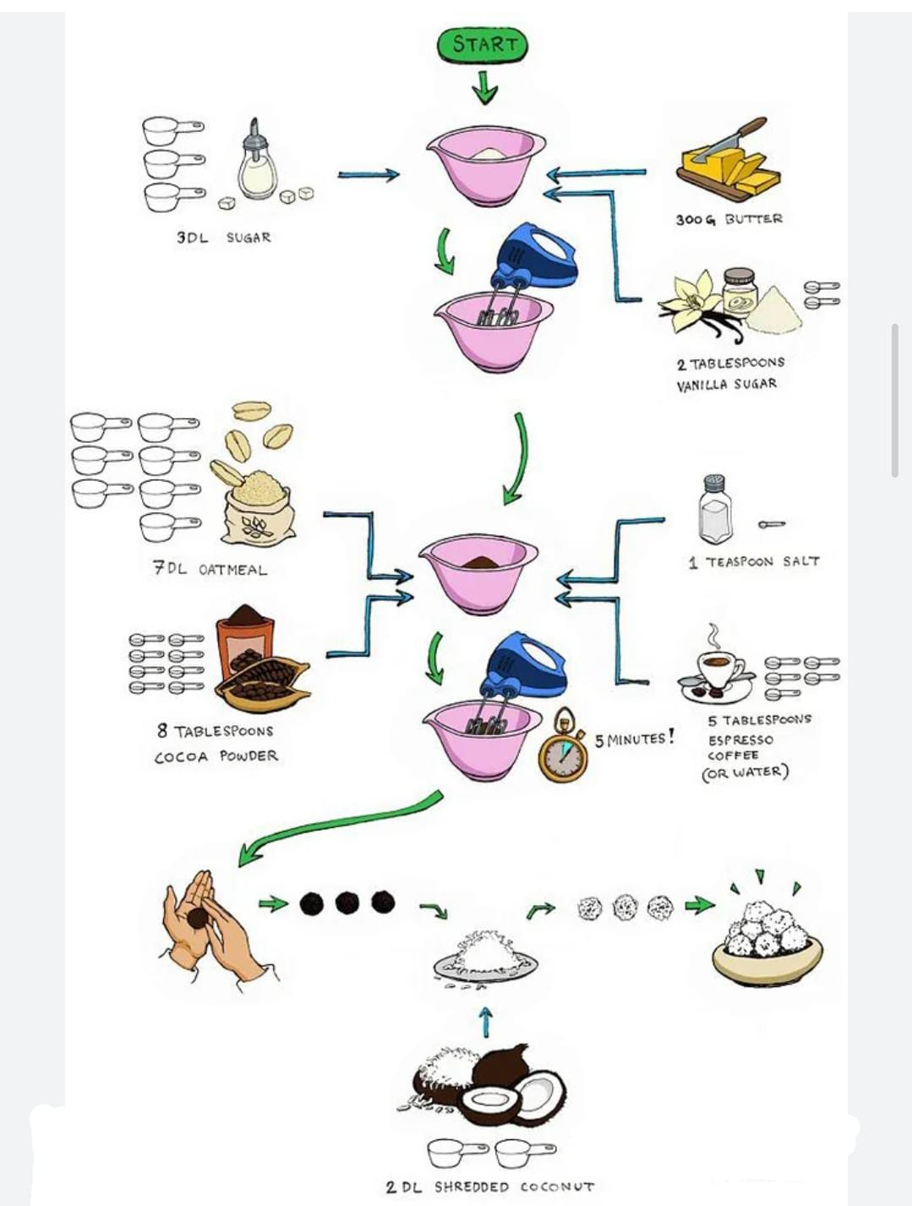
User Story Table – Flavour Fusion: -Ai-Driven Recipe Blogging

Use ID | User role  (Person) | As a.......  (WHO) | I Want.............  (what) | So that.............  (why/goal) | Acceptance criteria
US-1 | Food Blogger | user | As a blogger, I want to automatically generate a detailed blog post (including recipe, description, and tags) from my cooking process. | I can save time on manual content creation and publish regularly | Generates a 300+ word blog post with structured JSON-LD recipe markup.
US-2 | Culinary Adventurer | user | Combine two different cuisines (e.g., Thai + Italian) via a search prompt. | I can explore new, innovative taste experiences. | The model produces a recipe using key ingredients from both cultures with clear, step-by-step instructions
US-3 | Home Cooking | user | Upload an image of leftover ingredients in my fridge. | The AI can suggest a unique fusion recipe to reduce food waste. | System recognizes 90%+ of ingredients from an image and generates a valid, coherent recipe
US-4 | Content Creator | Owner | Have the AI auto-generate a blog post, including title, SEO meta-description, and image descriptions. | I can save time on manual content creation and publish regularly | The AI generates a 300+ word article that is coherent, engaging, and relevant to the generated recipe.
US-5 | Aspiring Cheif | user | view a detailed, step-by-step recipe generated from a picture | I can learn to cook complex dishes without having to read long, traditional blog posts. | The generated recipe includes ingredients, cooking times, difficulty levels, and clear instructions.
US-6 | Health-Conscious User | user | Request a gluten-free or vegan version of a recipe. | I can adapt my diet without losing flavor, and the AI handles the ingredient substitutions. | The AI suggests appropriate substitutions (e.g., tofu for meat) while keeping the dish within the specified dietary limits.

